
Tribhuvan University
Institute of Science and Technology

Lab Report on
Software Project Management

Submitted to:
Mr. Anup Raj Poudel
Department of Bachelor of Science in Computer Science and Information Technology (BSc.CSIT)
National College of Computer Studies

In partial fulfillment of the requirement for the degree of Bachelor of Science in Computer Science and Information Technology (BSc.CSIT)

Submitted by:
Atullya Maharjan [28863/078]
Regd. No.: 5-2-551-67-2021

Table of Content
S.N | Title | Date | Signature
1 | Design and Construction of PERT for some scenario/problem.
2 | Design and Construction of CPM with critical path value for some scenario/problem.
3 | Design and Construction of PDM with critical path value for some scenario/problem.
4 | Design and Construction of Bubble Chart for some scenario/problem.
5 | Design and Construction of Gantt Chart for some scenario/problem.
6 | Design and Construction of Slip Line Chart for some scenario/problem.
7 | Cost Benefit Analysis including IRR, NPV etc. for some scenario/problem.
8 | Earned Value Analysis including SPI, CPI etc. for some scenario/problem.

Lab 1: Design and Construction of PERT

Objective

To apply PERT estimation techniques and identify the critical path for an event booking system using MS Project.

Theory

PERT (Program Evaluation and Review Technique):
A project management tool used to plan, schedule, and control complex projects.
- Key Concepts:

Events/Nodes: Represent the start or completion points of activities.

Activities/Tasks: Work performed between events.

Optimistic Time (O): Minimum possible time to complete an activity.

Most Likely Time (M): Most probable time required.

Pessimistic Time (P): Maximum possible time to complete an activity.

Expected Time (TE): Weighted average calculated as:

TE= $\frac{O+4M+P}{6}$

Critical Path: Longest path in the network; determines the minimum project duration.

Slack/Float: Time an activity can be delayed without affecting project completion.

Scenario / Problem Statement

Project: Organizing a College Seminar
Activities:
Activity | Predecessor | Optimistic (O) | Most Likely (M) | Pessimistic (P)
A: Book Venue | - | 1 | 2 | 3
B: Prepare Invitation | - | 2 | 3 | 4
C: Arrange Equipment | A | 1 | 2 | 3
D: Send Invitation | B | 1 | 2 | 3
E:Conduct Seminar | C, D | 1 | 2 | 3

PERT Network Diagram

The PERT network diagram presents the logical sequence of project activities, showing how tasks are interconnected through dependencies. Each activity is represented as a node, with arrows indicating the flow and order of execution. This visualization makes it easier to determine the critical path and understand how any delay in one task could affect the overall project schedule.
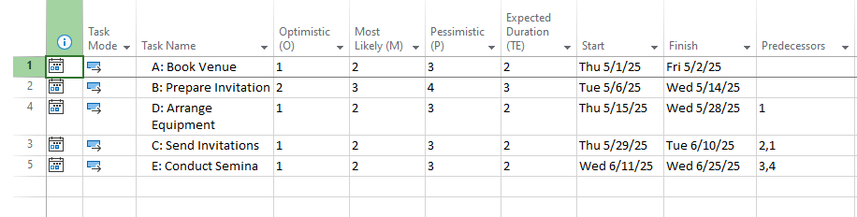

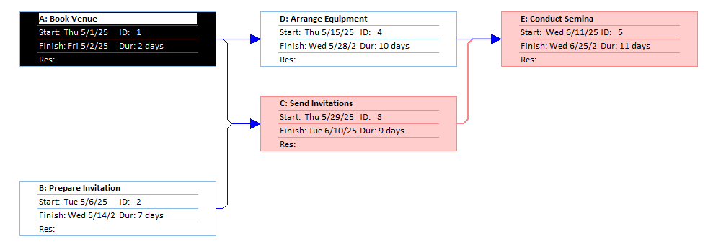
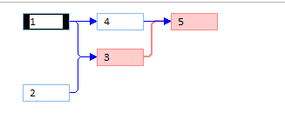

Results

Critical Path: B → C → E

Project Duration: 7 days

Slack/Float: Activities A and D have 1 day float (non-critical activities).

Conclusion

The PERT analysis shows a total project duration of 7 days with the critical path B → C → E. Activities A and D have 1-day float, providing some flexibility, while critical activities must be closely monitored to ensure timely project completion.

Lab 2: Design and Construction of CPM with critical path value for some scenario/problem.

Objective

To understand and apply the Critical Path Method (CPM) for project scheduling.

To construct a CPM network diagram for a given scenario and calculate the critical path and project duration.

Theory

CPM (Critical Path Method):
A project management tool used to plan, schedule, and control projects by identifying critical activities that directly affect the project completion time.

Key Concepts:

Activities/Tasks: Work to be performed in the project.

Events/Nodes: Start and completion points of activities.

Duration: Time required to complete an activity.

Earliest Start (ES) and Earliest Finish (EF): Earliest times an activity can start and finish.

Latest Start (LS) and Latest Finish (LF): Latest times an activity can start and finish without delaying the project.

Critical Path: Sequence of activities with zero slack, determining the shortest time to complete the project.

Slack/Float: Time an activity can be delayed without affecting overall project duration.

Scenario / Problem Statement
- Project: Construction of a Small Garden Shed
- Activities:
Activity | Predecessor | Duration (days)
A: Clear Land | - | 2
B: Lay Foundation | A | 3
C: Build Frame | B | 4
D: Install Roof | C | 2
E: Paint Walls | C | 3
F: Install Door & Windows | D, E | 1

CPM Network Diagram
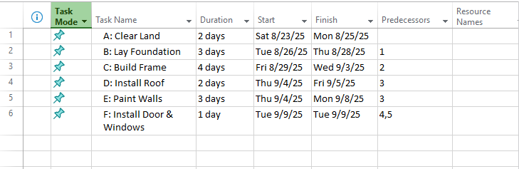

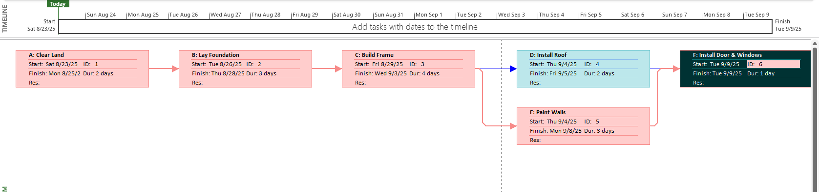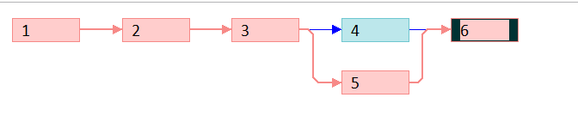

Results

Critical Path: A → B → C → D → F

Project Duration: 13 days

Slack/Float:

Activity E has 3 days of float (non-critical).

Lab 3: Design and Construction of PDM with critical path value for some scenario/problem.

Objective

To understand and apply the Precedence Diagram Method (PDM) for project scheduling.

To construct a PDM network diagram and calculate the critical path and project duration.

Theory

PDM (Precedence Diagram Method):
A project management technique used to create network diagrams where activities are represented by nodes (boxes) and arrows indicate dependencies.

Key Concepts:

Activity on Node (AON): Activities are shown as boxes (nodes).

Dependencies / Relationships:

Finish-to-Start (FS): Task cannot start until predecessor finishes (most common).

Start-to-Start (SS): Task cannot start until predecessor starts.

Finish-to-Finish (FF): Task cannot finish until predecessor finishes.

Start-to-Finish (SF): Rare; task cannot finish until predecessor starts.

Duration: Time required to complete an activity.

Critical Path: Sequence of activities with zero slack determines project completion time.

Slack / Float: Time an activity can be delayed without delaying the project.

Scenario / Problem Statement

Project: Organizing a Workshop Event
Activity | Predecessor | Duration (days)
A: Arrange Venue | - | 2
B: Prepare Materials | - | 3
C: Invite Speakers | B | 2
D: Setup Equipment | A | 1
E: Conduct Rehearsal | C, D | 2
F: Final Workshop | E | 1

PDM Network Diagram

Draw nodes for each activity and connect with arrows showing dependencies (AON style). 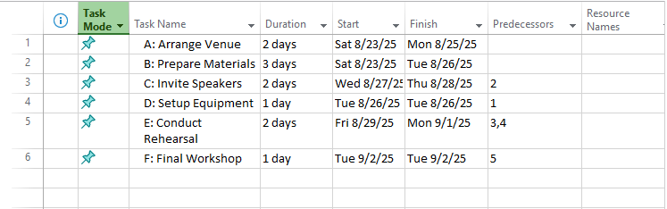
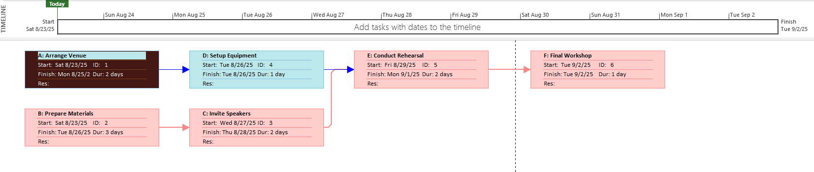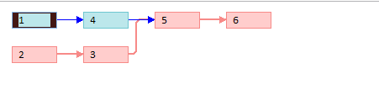

Results

Critical Path: B → C → E → F

Project Duration: 8 days

Slack/Float:

Non-critical activities: A → D

Conclusion

PDM helps visualize activity sequences and dependencies clearly. Critical path highlights tasks that directly affect project duration.

Lab 4: Design and Construction of Bubble Chart for some scenario/problem.

Objective

To understand the purpose and application of bubble charts in visualizing data.

To construct a bubble chart for a given scenario/problem to display relationships among three variables.

Theory

Bubble Chart: A type of chart that displays three dimensions of data:

X-axis: First variable (independent variable)

Y-axis: Second variable (dependent variable)

Bubble Size: Represents the third variable (magnitude or weight)

Purpose:

Visualize relationships between three numerical variables in a single chart.

Compare and anaylze patterns, trends, and outliers in data.

Key Components:

X-axis variable

Y-axis variable

Bubble size (magnitude of third variable)

Scenario / Problem Statement

Project: Compare Productivity of Employees

Objective: Visualize the relationship between Hours Worked, Tasks Completed, and Performance Rating of employees.
Employee | Hours Worked (X) | Tasks Completed (Y) | Performance Rating (Bubble Size)
Atullya | 40 | 15 | 8
Medhavi | 35 | 12 | 6
Roshan | 45 | 18 | 9
Rajesh | 30 | 10 | 5
Roman | 50 | 22 | 10

Creation of Bubble Diagram
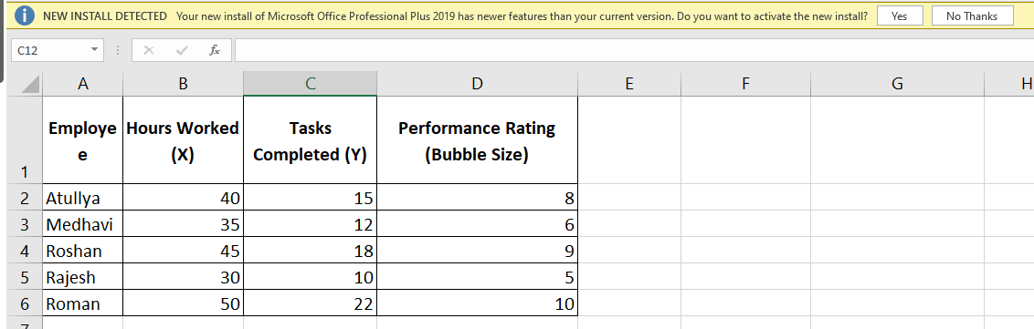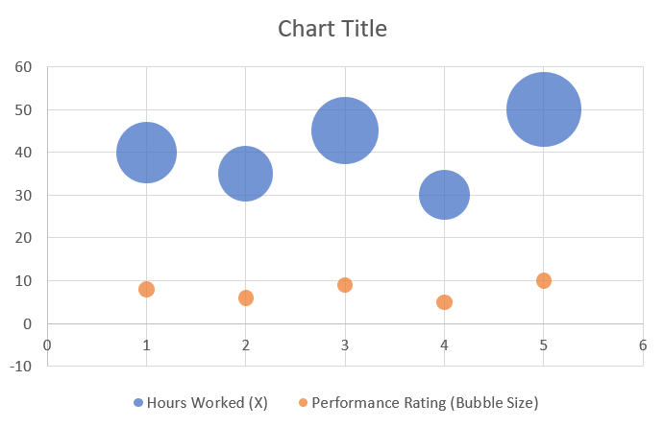

Results

The chart shows:

Higher Hours Worked generally correlates with more Tasks Completed.

Larger bubbles indicate higher Performance Ratings.

Outliers can be easily identified (e.g., someone working fewer hours but completing many tasks).

Conclusion

Bubble charts are effective for visualizing relationships among three variables. They help identify trends, correlations, and outliers in data. Useful in business, project management, and data analysis to make informed decisions.

Lab Sheet 5: Design and Construction of Gantt Chart for some scenario/problem.

Objective

To understand the purpose and application of Gantt charts in project management.

To construct a Gantt chart for a given scenario/problem to visualize the project schedule, durations, and dependencies.

Theory

A Gantt chart is a bar chart that represents the project schedule. Each task is represented by a horizontal bar, with the length of the bar proportional to the task duration.

Key Components:

Tasks/Activities: Listed vertically.

Timeline: Displayed horizontally (days, weeks, or months).

Bars: Represent the duration of each activity.

Dependencies: Arrows or links showing relationships between tasks.

Milestones: Key events or deliverables, often represented as diamonds.

Purpose:

Visualize project schedule.

Identify overlaps, dependencies, and critical tasks.

Assist in resource planning and progress tracking.

Construction of Gantt Chart
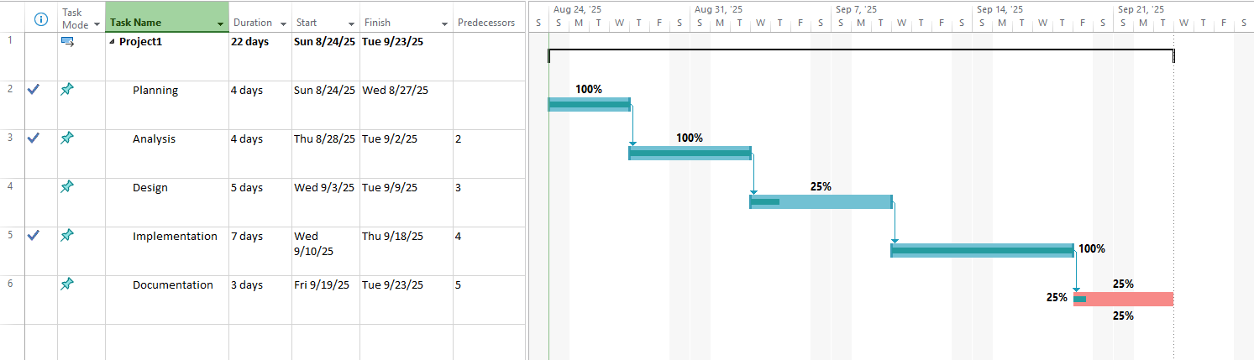

Result

The Gantt chart shows each task as a horizontal bar, proportional to its duration. Dependencies are clearly represented with arrows connecting tasks. Overlapping tasks (like A and B) can be seen, showing parallel activity execution.

Conclusion

Gantt charts provide a clear visual representation of the project schedule, showing task durations, dependencies, and sequence of activities. The critical path highlights tasks that directly affect project completion, helping managers focus on key activities.

Lab Sheet 6: Design and Construction of Slip Line Chart for some scenario/problem.

Objective

To understand the purpose of a Slip Line Chart in project management.

To construct a slip line chart for a scenario to analyze progress of tasks against planned schedule.

Theory

A slip line chart is used to track the deviation of actual progress from planned progress.

Key Components:

X-axis: Time (days, weeks, or months)

Y-axis: Cumulative work completed or % of task completed

Lines:

Planned Progress Line: Represents the schedule baseline

Actual Progress Line: Represents real progress

Purpose:

Identify delays or slips in the project schedule.

Monitor whether the project is ahead or behind schedule.

Construction of Slip Line Chart
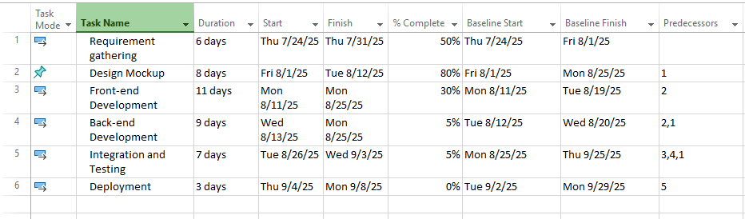
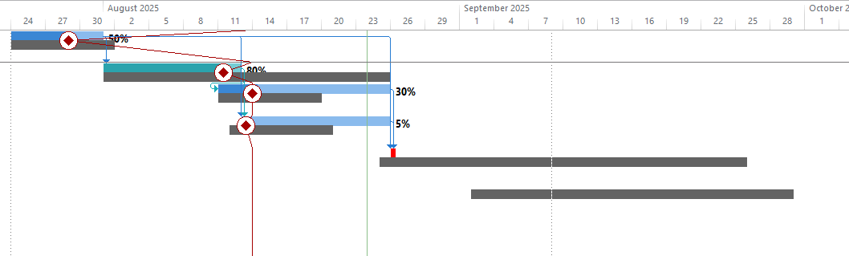

Results

The project is behind schedule, with delays in Design Mockup, Back-end Development, and Integration & Testing. Requirement Gathering is 50% complete; Front-end and Back-end are partially delayed.Slip chart highlights where corrective actions are needed.

Conclusion

Slip charts help monitor progress and identify delays. Useful for rescheduling tasks and ensuring timely project completion.

Lab 7: Cost Benefit Analysis including IRR, NPV etc. for some scenario/problem.

Objective

To understand and apply Cost Benefit Analysis (CBA) for evaluating project feasibility.

To calculate Net Present Value (NPV), Internal Rate of Return (IRR), and Payback Period for a project scenario.

Theory

A financial analysis method to evaluate the economic feasibility of a project by comparing total costs with total benefits.

Key Terms:

NPV (Net Present Value):

NPV=$\sum_{t=0}^{n}{\frac{Bt-Ct}{{\left(1+r\right) }^{t}}}$

B_{t} = Benefit at time t

C_{t} = Cost at time t

r = Discount rate

n = Number of periods

Decision: NPV > 0 → project is financially viable

IRR (Internal Rate of Return):

Discount rate at which NPV = 0

Higher IRR than required rate of return → project acceptable

Payback Period:

Time required to recover the initial investment

Purpose:

Evaluate financial viability

Compare alternatives

Assist in decision-making

3 Calculation
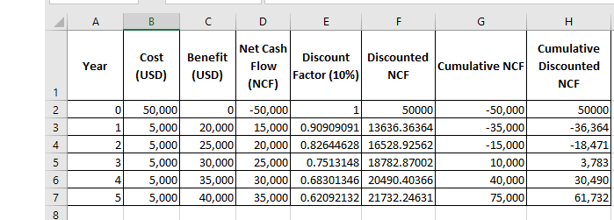
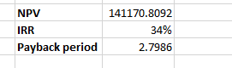

NPV: =SUM(F2:F7)

IRR: =IRR(D2:D7,-0.2)

Payback period =MIN(IF(G2:G7>=0,ROW(G2:G7)-ROW(G2)))

Observation:

The project’s NPV was positive (141,1170), IRR was 34% (well above the discount rate), and the payback period was about 2.8 years.

Conclusion:

Since the project has a high IRR, quick payback, and positive NPV, it is financially attractive and worth investing in.

Lab 8: Earned Value Analysis including SPI, CPI etc. for some scenario/problem.

Objective

Apply Earned Value Management to evaluate project schedule and cost performance.

Compute PV, EV, AC, SPI, CPI, SV, CV, EAC, for a practical scenario.

Theory

PV (Planned Value): Budgeted cost of work scheduled up to status date.

EV (Earned Value): Budgeted cost of work performed = Σ(BAC_task × % complete).

AC (Actual Cost): Actual money spent up to status date.

SV = EV − PV (schedule variance)

CV = EV − AC (cost variance)

SPI = EV / PV (schedule performance index)

CPI = EV / AC (cost performance index)

BAC: Budget at Completion (total planned budget)

EAC (common formula): BAC / CPI

Earned Value Calculation
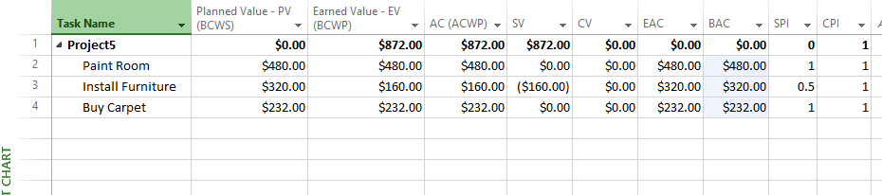

Resource Sheet
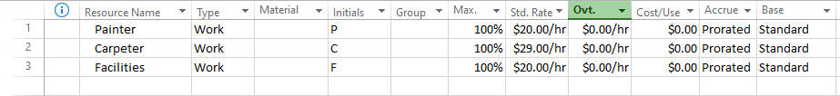

Gantt Chart
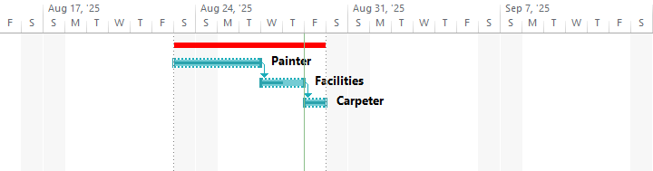

Earned Value Report
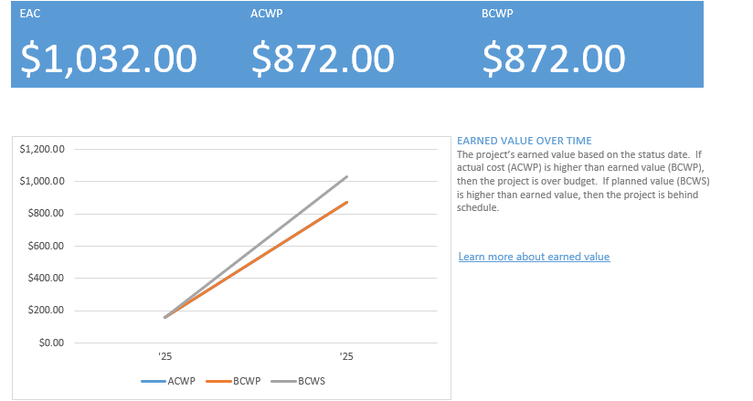

Conclusion:

It was observed that Earned Value Analysis helped monitor project performance effectively. Metrics like SV, CV, SPI, and CPI, showed that the project was behind schedule and over budget. It also helped forecast future costs and guided corrective actions.

